LAB ACTIVITY 3(iii):

Making Decision In Python

**Learning Outcomes:**

By the end of this laboratory session, you should be able to:

1. Construct List in simple program

**Hardware/Software:** Computer, Phyton 3.5 or above.

**Activity 3M**

Activity Outcome**:** List method in Python (method **clear()**)

Procedure:

**Step 1:** Open Code editor and type the code based on the following code :

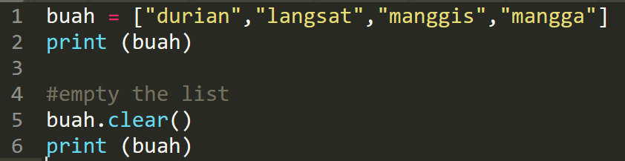

**Step 2:** Save, compile and run the program. Save the program as Act3M.py. Display the output in the area below.

**Output:**



**Activity 3N**

Activity Outcome: List method in Python (method **pop()**)

Procedure:

**Step 1:** Open code editor and type the following code:

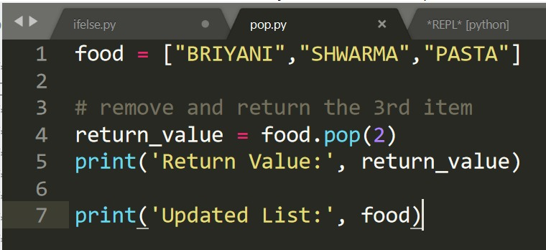

**Step 2:** Save, compile and run the program. Save the program as Act3N.py. Display the output in the area below.

**Output:**



**Activity 3O**

Activity Outcome : List method in Python (method **remove()**)

Procedures:

**Step 1:** Open code editor and type the following code:

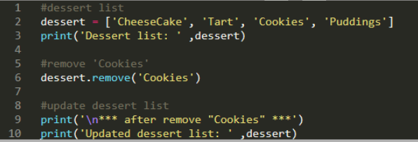

**Step 2:**  Save, compile and run the program. Save the program as Act3O.py. Display the output in the area below..

**Output:**

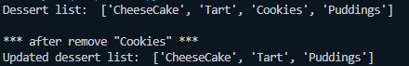

**Activity 3P**

Activity Outcome : List method in Python (method **reverse()**)

Procedures:

**Step 1:** Open code editor and type the following code:

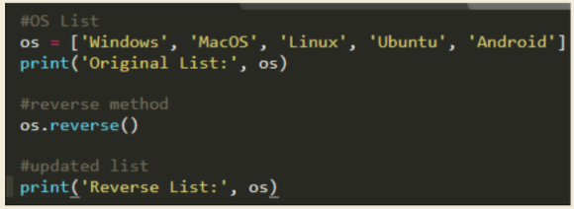

**Step 2:**  Save, compile and run the program. Save the program as Act3P.py. Display the output in the area below..

**Output:**



**Activity 3Q**

Activity Outcome : List method in Python (method **sort()**)

Procedures:

**Step 1:** Open code editor and type the following code:

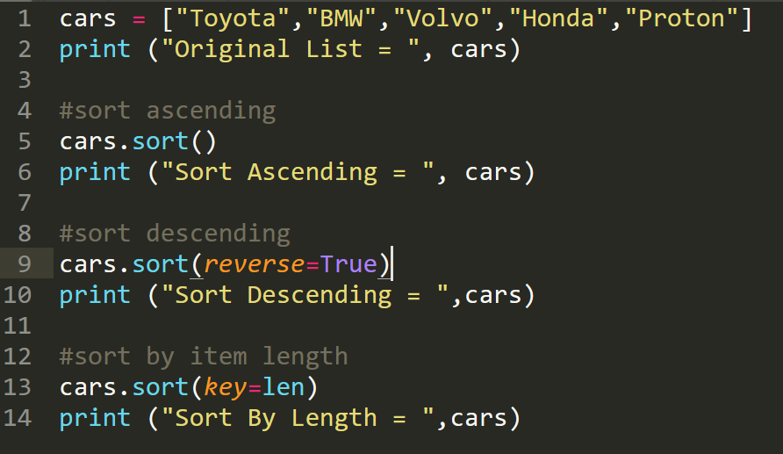

**Step 2:**  Save, compile and run the program. Save the program as Act3Q.py. Display the output in the area below..

**Output:**

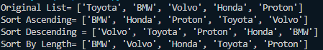

**Activity 3R**

Activity Outcome : List method in Python (method **append()**)

Procedures:

**Step 1:** Open code editor and type the following code:

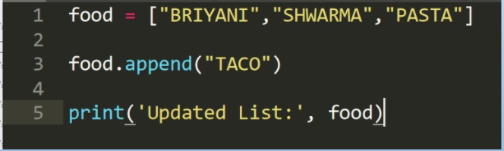

**Step 2:**  Save, compile and run the program. Save the program as Act3R.py. Display the output in the area below..

**Output:**



**Activity 3S**

Activity Outcome : List method in Python (method **extend()**)

Procedures:

**Step 1:** Open code editor and type the following code:

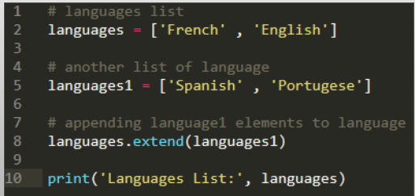

**Step 2:**  Save, compile and run the program. Save the program as Act3S.py. Display the output in the area below..

**Output:**



**Activity 3T**

Activity Outcome : List method in Python (method **insert()**)

Procedures:

**Step 1:** Open code editor and type the following code:

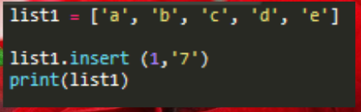

**Step 2:**  Save, compile and run the program. Save the program as Act3T.py. Display the output in the area below..

**Output:**



**Activity 3U**

Activity Outcome : List method in Python (method **index()**)

Procedures:

**Step 1:** Open code editor and type the following code:

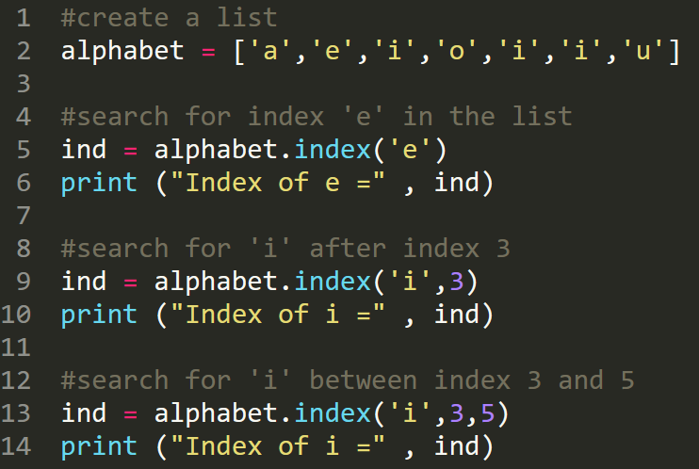

**Step 2:**  Save, compile and run the program. Save the program as Act3U.py. Display the output in the area below..

**Output:**

**Activity 3V**

Activity Outcome : List method in Python (method **copy()**)

Procedures:

**Step 1:** Open code editor and type the following code:

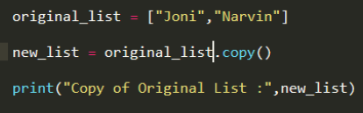

**Step 2:**  Save, compile and run the program. Save the program as Act3V.py. Display the output in the area below..

**Output:**



**Activity 3W**

Activity Outcome : List method in Python (method **count()**)

Procedures:

**Step 1:** Open code editor and type the following code:

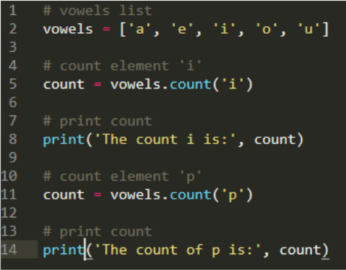

**Step 2:**  Save, compile and run the program. Save the program as Act3W.py. Display the output in the area below..

**Output:**

